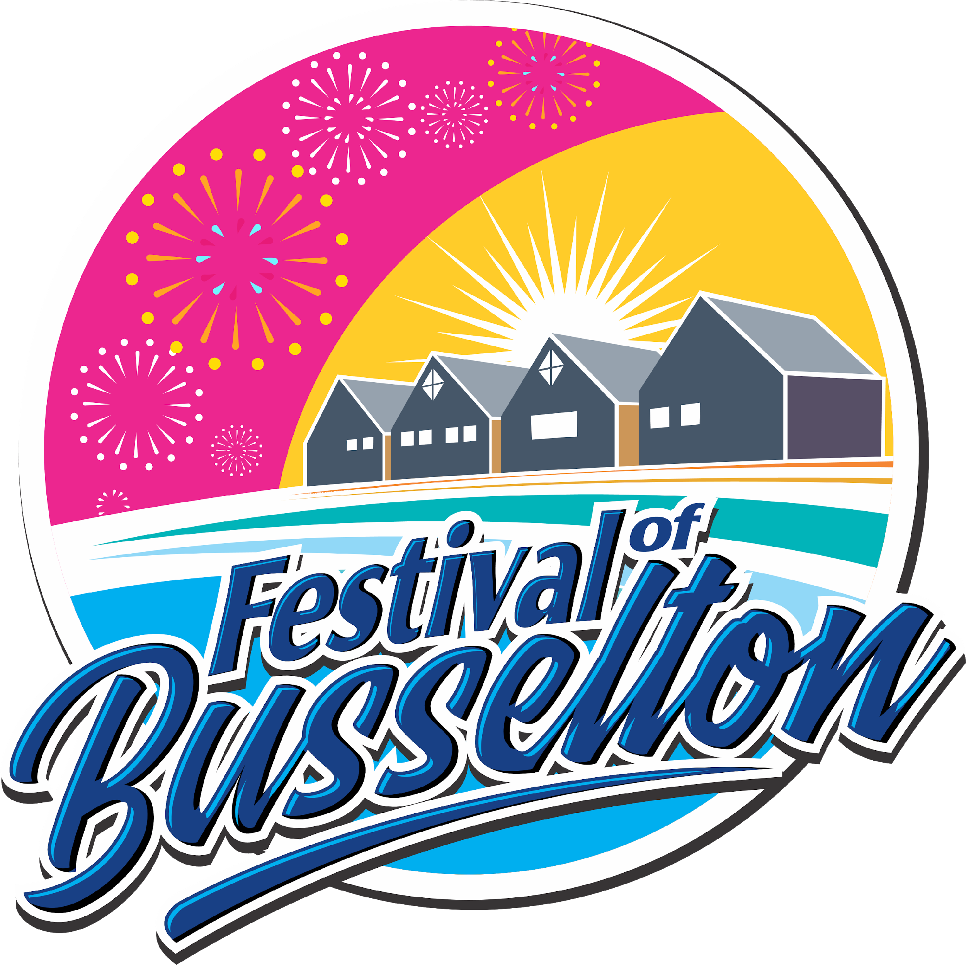 | Festival of Busselton 2020

Volunteer Registration Form

Applicant Information
Full Name: |  |  |  | Date of Birth:
 | Last | First

Address:

Street Address

 | City | State | Post Code

Phone: |  | Email:

Do you have a Working With Children Check? | YES | NO
If yes, please provide card number…………………………..and expiry date……………..
Do you have a current First Aid Certificate? | YES | NO
Have you completed any Covid Safety Training Courses? | YES | NO
If yes, please provide the course name/s………………………………………..……………..

Events
Please indicate which event/s you are able to assist with;

New Year’s Eve - Mucky Duck | 31/12/2020 | 5pm-10pm
Outdoor Cinemas 1 | 4/01/2021 | from 7.30pm
Sausage Dog Race | 9/01/2021 | TBC 9.00am
Water Fight | 9/01/2021 | 3.00pm
Eats & Beats | 10/01/2021 | 5.00pm-7.30pm
Outdoor Cinema Rio | 10/01/2021 | from 7.30pm
Outdoor Cinema 2 | 11/01/2021 | from 7.30pm
Chalk Art | 12/01/2021 | 10am-12pm
Outdoor Cinema 3 | 18/01/2021 | from 7.30pm
Petticoat Lane | 20/01/2021 | 6pm-9pm
Main Event | 23/01/2021 | 6pm-9.30pm

Please note, the hours above are the hours of the event and your assistance may be required prior to and/or after these times.

More details on our events can be found at our website www.festivalofbusselton.com.au

